DEVELOPERSHUB
INTERNSHIP
Digital Marketing Internship - Week 1

Task: Research & Campaign Planning
Intern Name: Eman Saleem
Business: Nayyab Eman - Online Quran Tutor
Submission Date: 26 June 2026

- BUSINESS OVERVIEW
Business Name: Nayyab Eman - Online Quran Tutor

- Business description

- What the business does:
Online Quran & Tajweed classes for kids + adults worldwide. Noorani Qaida, correct pronunciation, correct recitation with Tajweed rules.

- What online platforms it currently uses:
Platforms: Facebook Page + Instagram Profile.
Content: Posts, Reels, Text.

- Target Audience:
Parents age: 25-45
Location: Pakistan, Saudi Arabia, UK, USA, Canada, Australia.
Interest: Islamic education, Hifz, Nazra Quran, Tajweed.
- Platforms:
Facebook: https://www.facebook.com/share/1Tg9jtPP9K/

Instagram: https://www.instagram.com/nayyabeman.quran.tutor

  - Proofs:

Facebook profile: 6.4k Followers
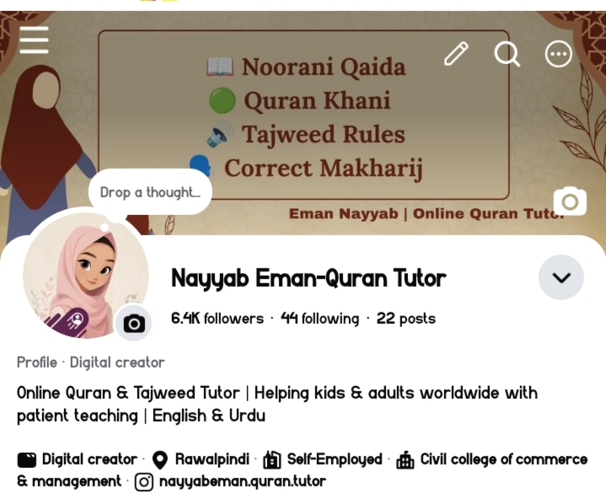
Instagram profile: 37 Followers

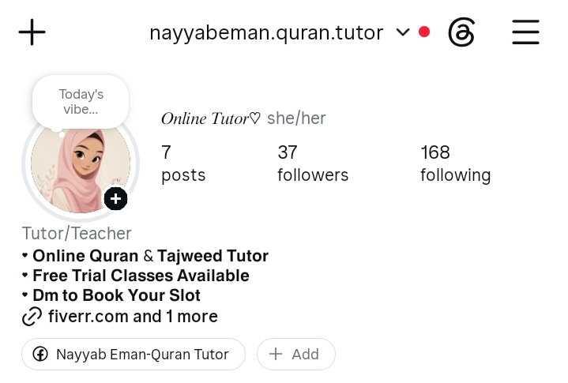

- Current Performances
& Insight
- Facebook:
- 2.1 Overall Performance
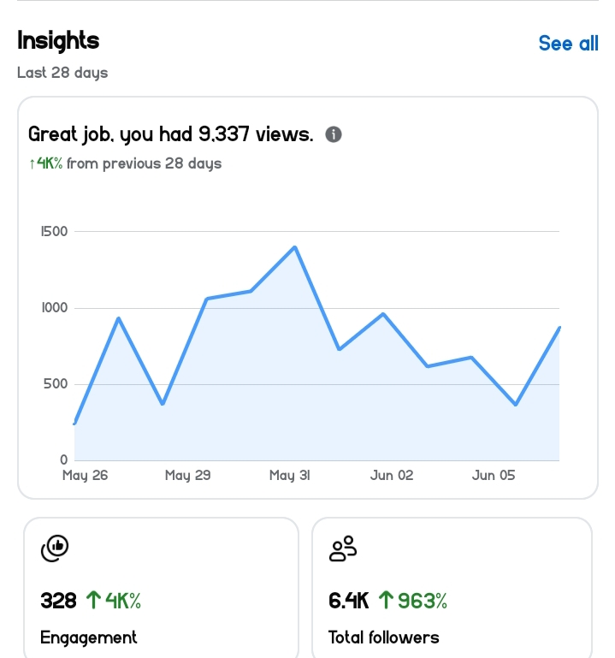

  - 2.2 Audience Demographics
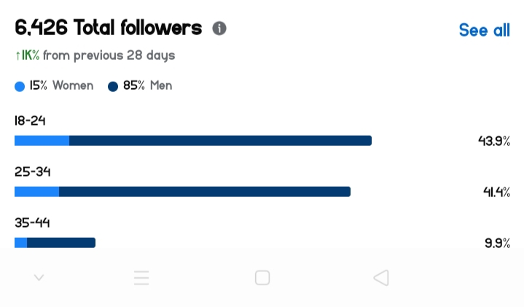

- 2.3 Content Type Performance
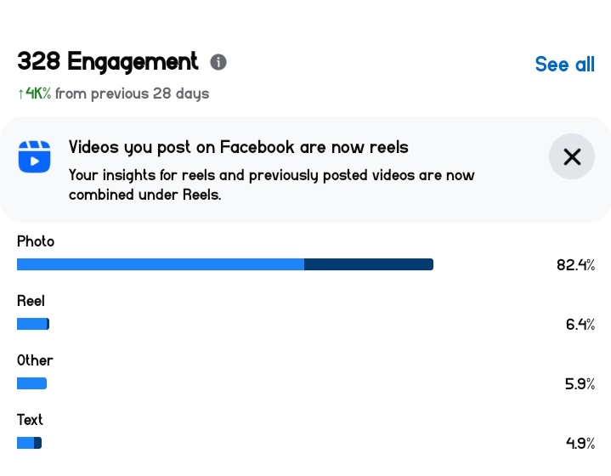
- 2.4 Top Performing Posts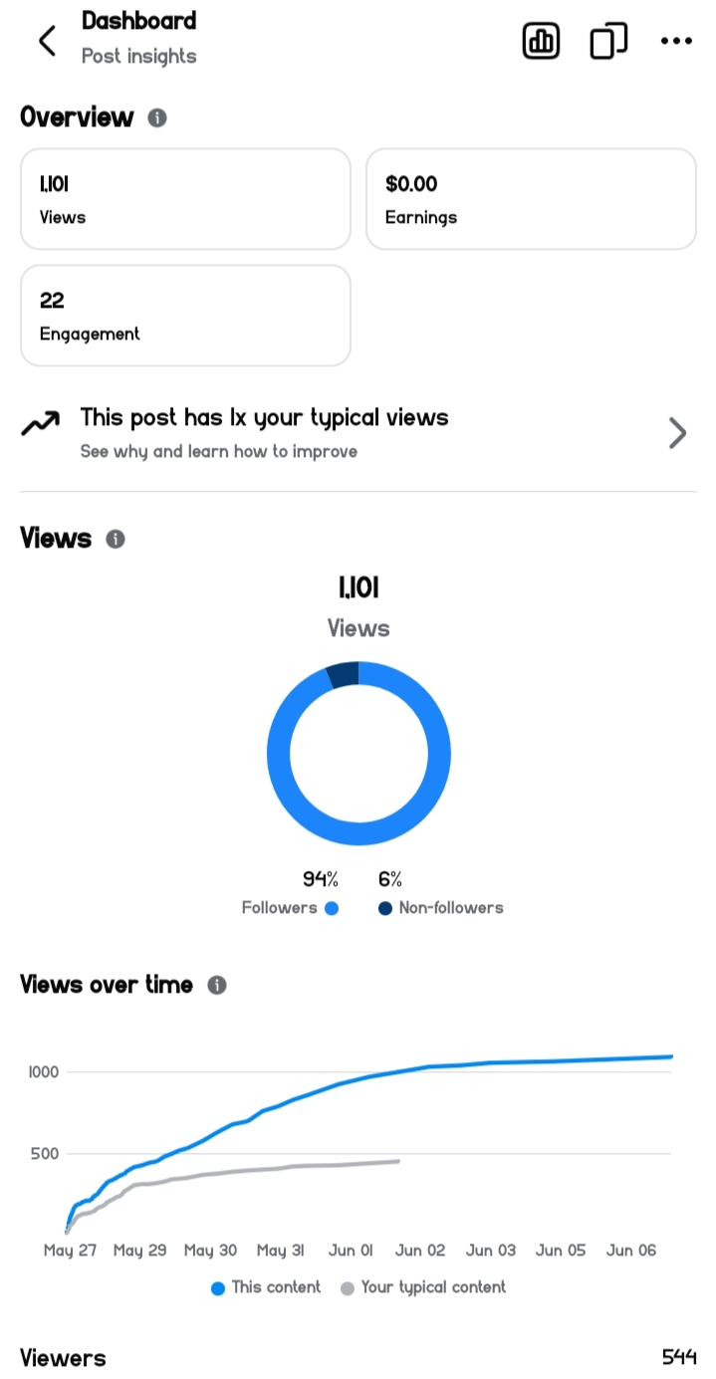

- 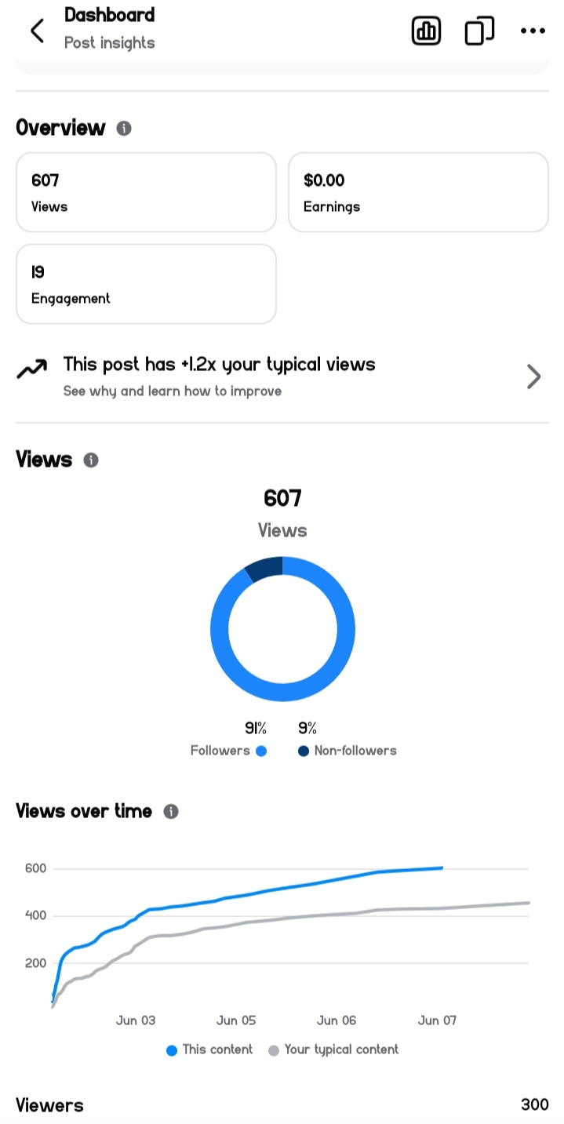
- 2.5 Geographic & Traffic Source
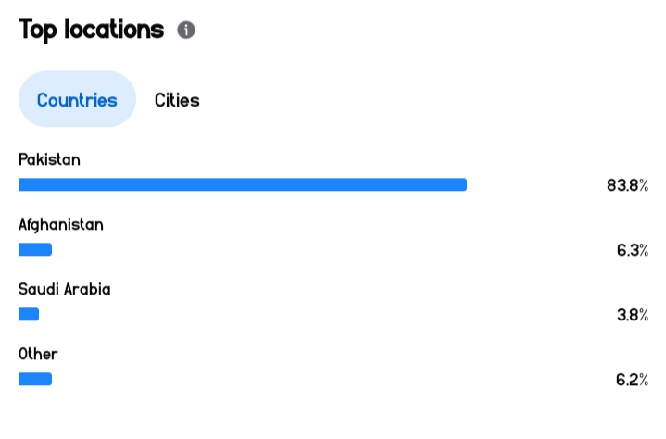

- Instagram:
2.1.1 Overall Performance

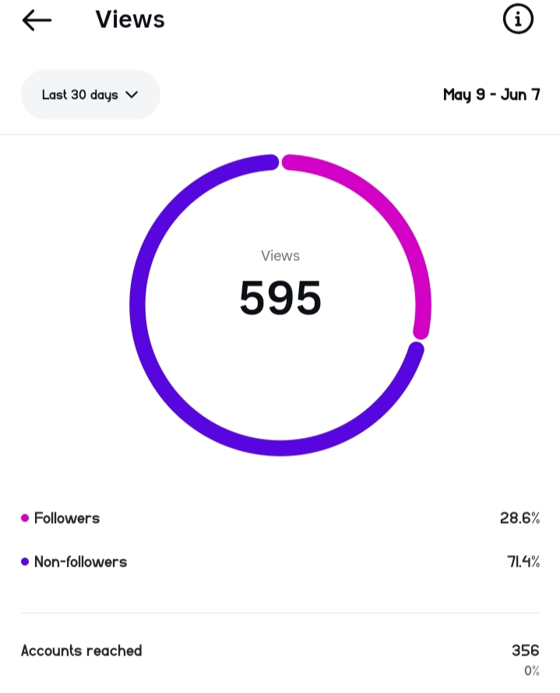
  - 2.2.2 Content Type Performance
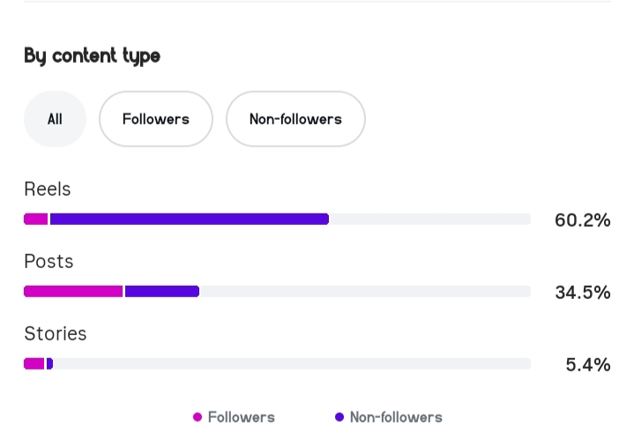

- 2.2.3 Top Performing Posts
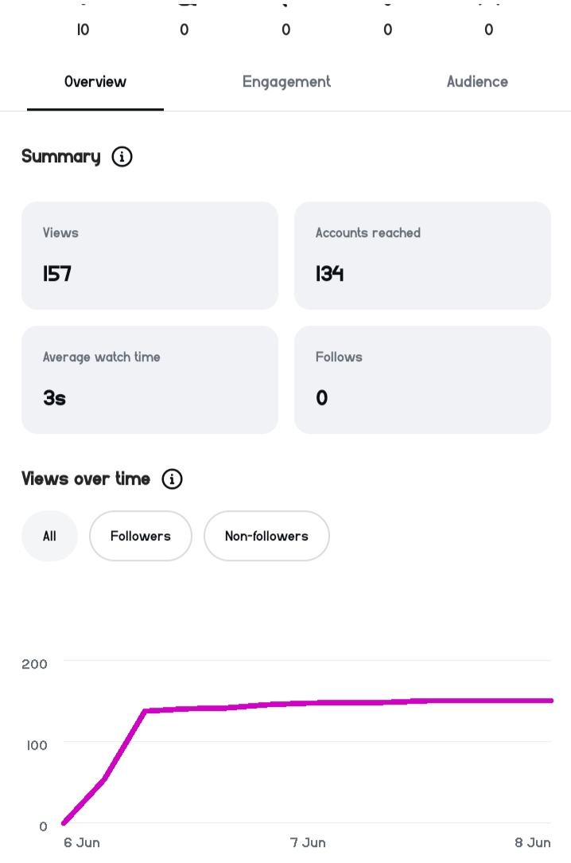

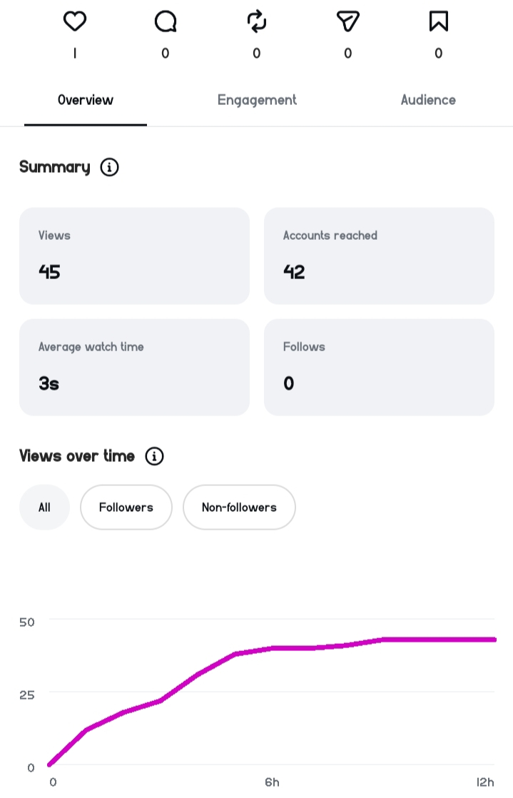

  - 2.2.4 Audience Demographics
  - 2.2.5 Geographic & Traffic Source
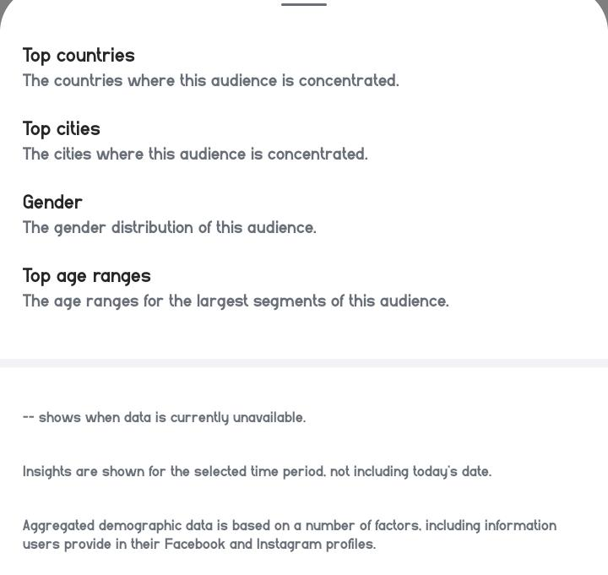

3.COMPETITOR ANALYSIS
Competitor name | Platform | Followers | Content | Weakness | Opportunity
Female Online Quran Tutor | Facebook | 9.8k | Live Classes, Reels | Poor Design Quality | Professional branded posts
Hafiza Qaria Online Quran Tutor | Facebook | 5.7k | Live classes, Ai generated content | Inconsistent posting | Consistent posting schedule
online_quran_  teacher | Instagram | 713 | Reels, post | Low quality posts | Professional branded posts
Quran.tutor46 | Instagram | 47 | Reels,  post | Low engagement | Content batch creation strategy

- CAMPAIGN GOALS – SMART
Goal | Metric | Target | Timeline | Smart justification
Brand Awareness | Social media followers | 300-400 followers through engagements | 6 weeks | Achievable with 1 Reel + 1 Post daily
Lead generation | Trial booking | 5-7  bookings | 6 weeks | 1-2 bookings per week for trial classes via DM/WhatsApp CTA
Engagement | Engagement rate | 10% per post | Weekly | Reply to all comments + Q&A stickers

- KEY PERFORMANCE INDICATORS
KPIs –
Goal | KPI | How to measure | Frequency
Brand awareness | Followers | Facebook/  Instagram insights | Weekly
Lead generation | Free trial classes | Dm / WhatsApp count | Weekly
Engagement | Engagement rate | Like/ Comments (Reach=50+) | Per Post

- Content Strategy
Content Type | Purpose | Example Topics | Platform
Educational Posts | Educate parents and students about Quran learning | Tajweed Tips, Noorani Qaida Lessons, Quran Learning Benefits | Facebook & Instagram
Reels | Increase reach and engagement | Quran Recitation Clips, Tajweed Demonstrations, Islamic Reminders | Facebook & Instagram
Student Testimonials | Build trust and credibility | Parent Feedback, Student Success Stories | Facebook & Instagram
Promotional Posts | Generate inquiries for new students | Free Trial Class Offer, Admissions Open | Facebook & Instagram
Islamic Awareness Content | Engage the audience | Islamic Quotes, Duas, Jummah Reminders | Facebook & Instagram
Teacher Introduction Content | Introduce the tutor and teaching style | Teaching Method, Experience, Online Class Environment | Facebook & Instagram
Organic Promotion | Grow audience without paid advertising | Hashtags, Reels, Community Sharing, Audience Engagement | Facebook & Instagram
Referral Campaign | Encourage existing students to recommend others | Student Referral Program, Family Recommendations | Facebook & Instagram
Future Blog Content (Optional) | Share detailed educational information if a website is created in future | Quran Learning Guides, Tajweed Articles | Future Website
Future Newsletter (Optional) | Share updates with parents if email communication is introduced in future | Course Updates, Student Achievements | Email (Future)

- Content Calendar
(Planned Content Schedule)
Day | Platform | Content Type | Topic/Idea | Objective
Monday | Instagram | Reel | Quran Recitation Clip | Increase Reach
Monday | Facebook | Educational Post | Tajweed Rule Day 1 | Educate Audience
Tuesday | Instagram | Reel | Tajweed Demonstration | Increase Engagement
Tuesday | Facebook | Promotional Post | Free Trial Class Information | Generate Inquiries
Wednesday | Instagram | Reel | Islamic Reminder | Increase Reach
Wednesday | Facebook | Educational Post | Tajweed Rule Day 2 | Educate Audience
Thursday | Instagram | Reel | Quran Learning Tip | Increase Engagement
Thursday | Facebook | Testimonial Post | Parent/Student Feedback | Build Trust
Friday | Instagram | Reel | Quran Recitation Clip | Increase Reach
Friday | Facebook | Educational Post | Tajweed Rule Day 3 | Educate Audience
Saturday | Instagram | Reel | Islamic Reminder | Increase Engagement
Saturday | Facebook | Promotional Post | Admissions Open / Free Trial Offer | Generate Leads
Sunday | Instagram | Reel | Student Achievement / Recitation | Build Credibility
Sunday | Facebook | Educational Post | Tajweed Rule Day 4 | Educate Audience

